India Primary Health Care Data

Understand Dataset Structure & Variables :-

The **India Primary Health Care Data** dataset from Kaggle provides comprehensive information on various health indicators, infrastructure, and services across different regions in India. This data is essential for conducting market research and segmentation, particularly in the healthcare sector.

**📊 Dataset Overview**

The dataset encompasses several key areas:

* **Health Indicators**: Data on vaccination rates, diarrheal prevalence, acute respiratory infections, and breastfeeding practices.
* **Infrastructure and Services**: Information on the number of health facilities, availability of essential drugs, and service delivery metrics.
* **Demographics**: Population statistics segmented by age, gender, and region.

**🔍 Analysis & Segmentation Approach**

**1. Geographic Segmentation**

* **State-Level Analysis**: Assess health indicators and infrastructure across different states to identify regional disparities.
* **District-Level Insights**: East Godavari district in Andhra Pradesh has the highest number of functional health and wellness centers.
* **Urban vs. Rural Comparison**: Examine differences in healthcare access and outcomes between urban and rural areas.

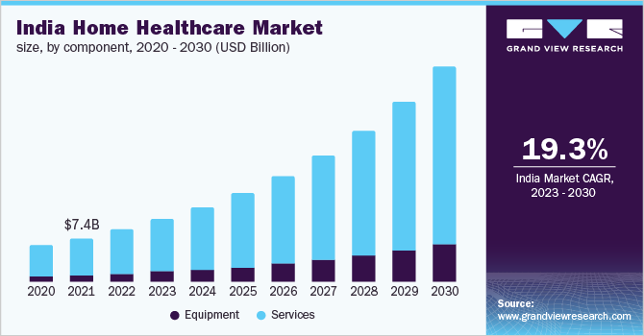

**2. Demographic Segmentation**

* **Age and Gender**: Analyze health data segmented by age groups and gender to understand specific needs.
* **Vulnerable Populations**: Identify groups with higher health risks, such as children under 5 or elderly populations.
* **Health Indicators**: Vaccination rates and breastfeeding practices show regional variations, with southern states generally performing better.
* **Disease Prevalence**: Higher incidences of acute respiratory infections and diarrheal diseases are reported in states like Uttar Pradesh and Bihar.
* **Access to Services**: Utilization of healthcare services is lower in rural areas, indicating potential barriers such as transportation and awareness.

**3. Healthcare Workforce Analysis**

* **Availability of Healthcare Workers**: Evaluate the distribution of doctors, nurses, and other healthcare professionals across regions.
* **Training and Capacity Building**: Identify areas with shortages in healthcare staff and potential needs for training programs.

**📈 Visualization & Insights**

To effectively communicate the findings, the following visualizations can be created:

* **Heatmaps**: To show regional variations in health indicators.
* **Bar Charts**: For comparing healthcare infrastructure across states.
* **Pie Charts**: To depict demographic distributions.
* **Trend Lines**: For analyzing changes over time in health metrics.

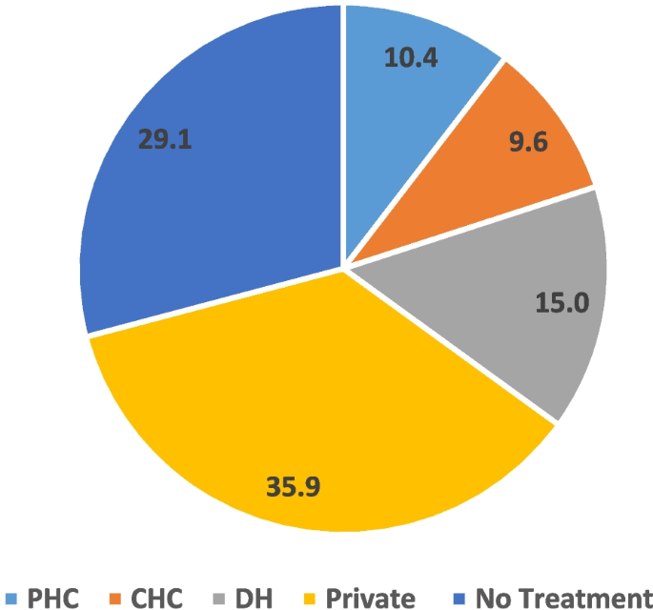

**🧭 Strategic Recommendations**

Based on the analysis, the following strategies can be considered:

* **Targeted Healthcare Programs**: Develop initiatives focused on regions or demographics with poor health indicators.
* **Resource Allocation**: Prioritize areas with healthcare worker shortages for training and recruitment.
* **Public Awareness Campaigns**: Focus on educating populations in regions with low vaccination or breastfeeding rates.

